2400032662 M.Praveen Reddy
GITHUB: PraveenReddy-06/Full-Stack-Lab

#SKILL - 9 ➔ Global Exception Handling using @ControllerAdvice
Prerequisites:
- Understanding of REST API exception flow
- Concept of custom exceptions

A university application provides student details through REST APIs. When users enter an invalid student ID, the system shows technical error messages that are difficult for users to understand. To improve usability, the application should return clear, readable, and user-friendly error responses through centralized exception handling.

Your task is to implement Global Exception Handling using @ControllerAdvice and create custom exceptions for invalid student inputs.

Tasks:

  - Create a custom exception class named StudentNotFoundException.
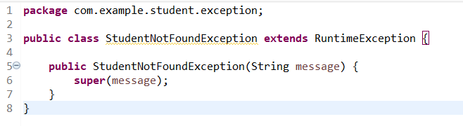
  - Create a REST endpoint /student/{id} that retrieves student information and throws the custom exception when the given student ID is invalid.
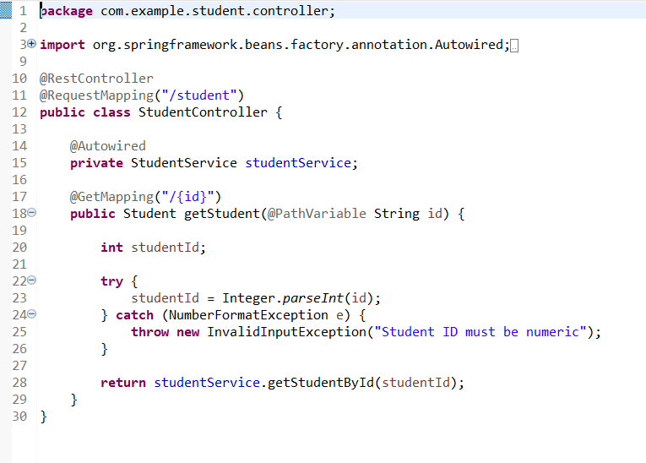
  - Create a GlobalExceptionHandler class using @ControllerAdvice to handle exceptions across the entire application.
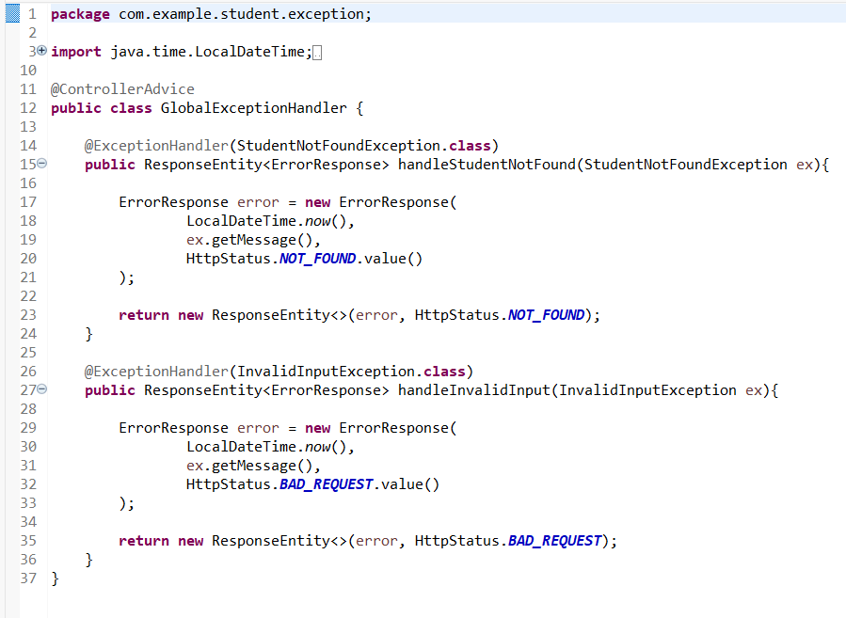
  - Add a method with @ExceptionHandler(StudentNotFoundException.class) to return a meaningful error response along with an appropriate HTTP status code.

  - Add a second custom exception, such as InvalidInputException, and handle it inside the same @ControllerAdvice class.

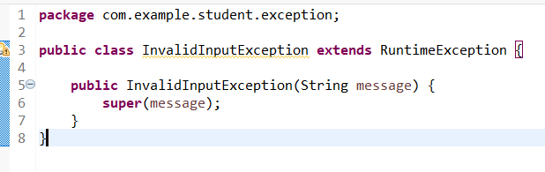
  - Return a structured JSON response (fields like timestamp, message, statusCode) from the exception handler to make the error readable and consistent. 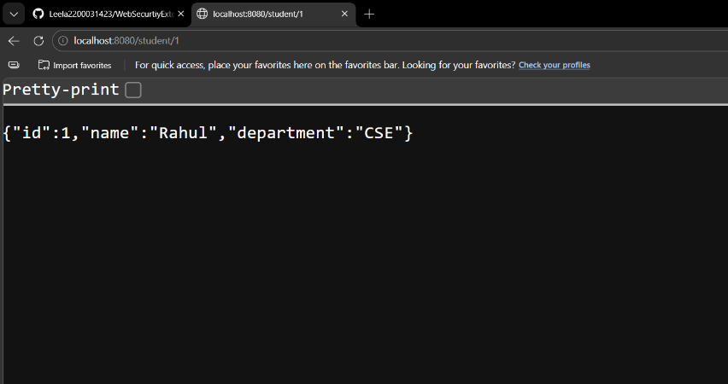

  - Test the API with valid and invalid student IDs and observe the difference in responses.

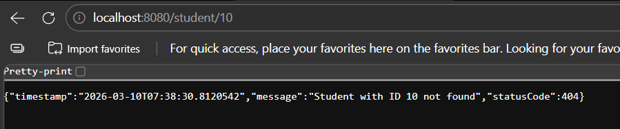
  - Test an endpoint with invalid input format (e.g., sending text instead of a number) to trigger the second custom exception using Postman.
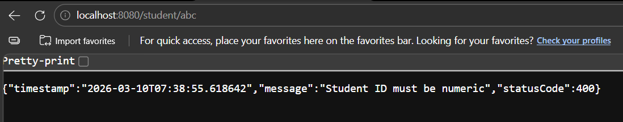
  - Push the Spring Boot project to GitHub.
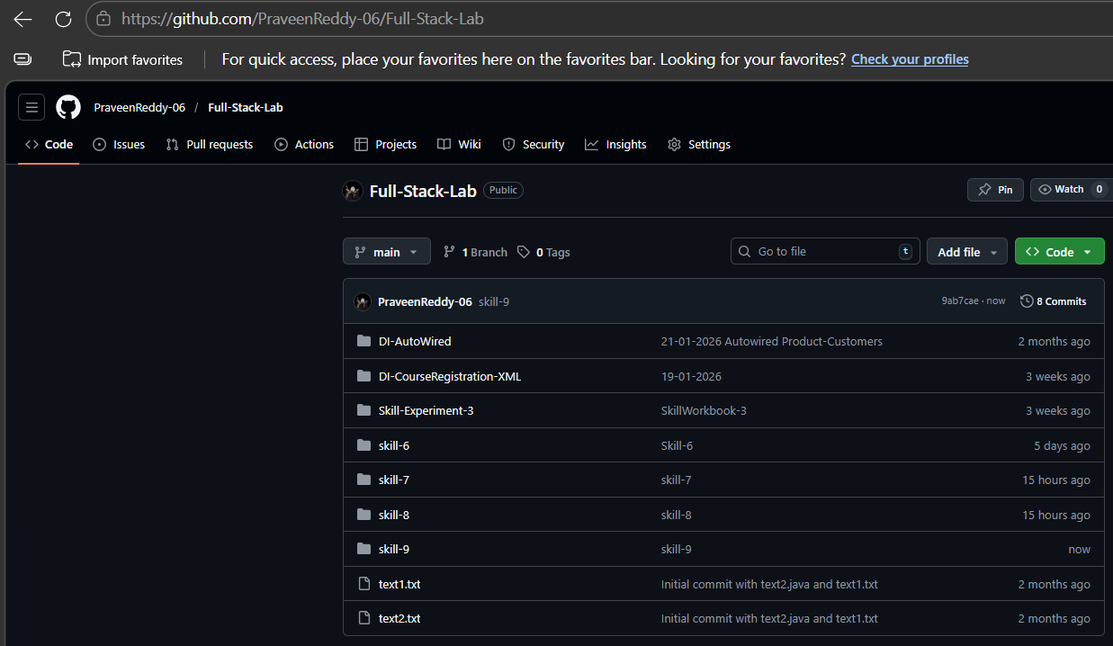
VIVA QUESTIONS:
1. What is the purpose of @ControllerAdvice in Spring?
@ControllerAdvice is used to handle exceptions globally across all controllers in a Spring Boot application. It centralizes exception handling logic instead of writing try-catch blocks in every controller.

2. How does @ExceptionHandler work inside a global handler?
@ExceptionHandler defines methods that handle specific exception types. When an exception occurs, Spring automatically calls the matching handler method and returns a custom response.

3. Why do applications use global exception handling?
Global exception handling provides:
- centralized error handling
- cleaner controller code
- consistent error responses
- better user-friendly API responses.

4. Difference between custom exceptions and default exceptions?
Default exceptions are built-in Java exceptions (NullPointerException, IllegalArgumentException).
Custom exceptions are user-defined exceptions created to represent specific application errors such as StudentNotFoundException.

5. Can a single @ControllerAdvice class handle multiple exceptions?
Yes. A single @ControllerAdvice class can handle multiple exceptions by defining multiple @ExceptionHandler methods for different exception types.

Comment of the Evaluator (if Any)

Evaluator’s Observation
Marks Secured: out of
EMP ID & Full Name of the Evaluator:

Signature of the Evaluator Date of Evaluation:

